Tour Planner Protocol

Project Overview
Project: Tour Planner
Course: SWEN 2
Stack: Angular 21, ASP.NET Core (.NET 10), Entity Framework Core, PostgreSQL, Serilog, NUnit, Vitest, Leaflet, OpenRouteService
The goal of the project was to build a web-based tour planning application with a clear frontend/backend split, a layered backend architecture, MVVM in Angular, persistence through PostgreSQL, external routing/geocoding integration, automated tests, and one mandatory unique feature.
The final application allows a user to:
- register and log in
- create, update, delete, and list tours
- calculate routes with external APIs and display them with Leaflet
- create, update, delete, and list tour logs
- search through tours and log-related text
- import and export tour bundles
- view computed attributes such as popularity and child-friendliness
- use a statistics dashboard as the mandatory unique feature

Startup Instructions
This section is intentionally explicit so the lector can start the project without guessing hidden configuration.

Required tools
- .NET SDK 10
- Node.js 20+
- npm 10+
- Docker Desktop

Secret/config files
Two example files are included to show the required secret structure:
- backend/.env.example
- backend/secrets.json.example
backend/.env configered like in backend/Secrets/.env.example is used by Docker Compose for PostgreSQL:
POSTGRES_DB=tourplanner
POSTGRES_USER=tourplanner
POSTGRES_PASSWORD=...

backend/Secrets/secrets.json.example shows the secret keys expected by the API:
{
"ConnectionStrings": {
"DefaultConnection": "Host=localhost;Port=5432;Database=tourplanner;Username=tourplanner;Password=..."
},
"Routing": {
"OpenRouteServiceApiKey": "..."
},
"Jwt": {
"SigningKey": "BASE64_ENCODED_32_BYTE_PLUS_SECRET"
}
}

Important:
- .env.example is copied to .env for Docker Compose.
- secrets.json.example is not loaded directly by ASP.NET at runtime. It documents which values must be stored in .NET User Secrets on the local machine.
- Jwt:SigningKey is mandatory. Without it, the API does not start.

Backend setup
- Copy the Docker environment file:
cd backend
Copy-item .env.example .env

- Start PostgreSQL and pgAdmin:
docker compose up -d
- Store the API secrets in .NET User Secrets:
dotnet user-secrets set --project TourPlanner.API "ConnectionStrings:DefaultConnection" "Host=localhost;Port=5432;Database=tourplanner;Username=tourplanner;Password=..."
dotnet user-secrets set --project TourPlanner.API "Routing:OpenRouteServiceApiKey" "..."
dotnet user-secrets set --project TourPlanner.API "Jwt:SigningKey" "BASE64_ENCODED_32_BYTE_PLUS_SECRET"

- Apply the EF Core migrations:
dotnet ef database update --project TourPlanner.DataAccessLayer --startup-project TourPlanner.API

- Start the API:
dotnet run --project TourPlanner.API

The development profile runs on:
- http://localhost:5102
- https://localhost:7248

Frontend setup
In a second terminal:
cd frontend/TourPlannerWeb
npm.cmd install
npm.cmd start

The Angular frontend runs on:
- http://localhost:4200

First login flow
Because the backend is protected by JWT authentication, the normal first step is:
- open /auth
- register a new user
- log in
- continue to dashboard, tours, and logs

Technical Steps And Decisions

Frontend architecture
The frontend was built with Angular using MVVM:
- pages and components focus on rendering and user interaction
- viewmodels contain UI logic, validation, and computed state
- services hold shared state and backend communication
- Angular signals/computed values act as the reactive update mechanism
This kept presentation logic out of the templates and made unit testing cheaper.

Backend architecture
The backend follows a layered architecture:
- API layer: controllers, DTOs, mappers, middleware
- Business layer: domain rules, validation, orchestration services
- Data access layer: repositories and EF Core persistence
- Domain layer: entity model and enums
This separation made it easier to test business logic without HTTP or database dependencies in every test.

Persistence and search
Entity Framework Core with PostgreSQL was selected because:
- it satisfies the OR-mapper requirement
- migrations are easy to version
- PostgreSQL offers strong full-text search support
For full-text search, PostgreSQL tsvector shadow columns and GIN indexes were used. This kept search logic inside the database instead of transferring large amounts of data into the application and searching in memory.

External APIs
External route data is not guessed locally:
- Nominatim is used for place search/geocoding
- OpenRouteService is used for route calculation
- Leaflet renders the map in the Angular frontend
This decision directly matches the assignment requirements and keeps the route/distance/time calculation realistic.

Authentication and securety
Authentication was implemented with:
- JWT access tokens
- refresh tokens
- password hashing with ASP.NET Identity hasher
- stricter password policy
- rate limiting on auth endpoints
- per-user data scoping enforced from controller down to repository
The scoping decision was especially important because the assignment explicitly says tours and logs must never be shared between users.

Logging
Serilog was chosen as the logging framework. It logs:
- request pipeline events
- repository operations
- business events such as create/update/delete
- file-based rolling logs plus console logs
This satisfies the logging requirement and is also useful during debugging and presentation.

Import/Export
Import/export was implemented as JSON because:
- it matches the HTTP/DTO structure already used in the project
- it is easy to inspect manually
- it supports full nested data export of tours with logs
Validation is done during import so a partially broken file does not silently corrupt the database.

Mandatory unique feature
The mandatory unique feature is a statistics dashboard.
Final design decision:
- pure frontend feature
- no new backend endpoint
- aggregates data already loaded for tours and tour logs

Reason:
- cheaper to implement
- minimal backend risk
- still clearly unique and demonstrable
- easy to test with pure aggregation logic
The feature computes:
- average kilometers per month
- rating distribution
- top tour
- transport mix
Important implementation note:
An unfinished backend statistics slice had already been started. The final solution kept the actual feature frontend-only and only added the missing backend interface implementation so the .NET solution builds again without introducing a new API endpoint.

Problems, Failures, And Selected Solutions

Search complexity
At first, search was simpler on the frontend, but that does not scale well and does not satisfy the idea of true full-text search across persisted data. The final solution moved search responsibility into PostgreSQL through indexed tsvector columns and a dedicated repository query.

Computed attributes
Popularity and child-friendliness depend on tour logs, so storing them directly risks stale data. The chosen solution was to recompute them after every log create/update/delete in TourLogService. This keeps read performance high while still preserving correctness.

Unique feature scope
A backend statistics endpoint was not necessary for the mandatory feature. The cleaner solution was to use existing tour/log data already available on the client and aggregate it inside a pure frontend helper. This reduced API surface area and kept the feature lightweight.

Validation and startup configuration
Keeping configuration out of source code was a must-have. The project therefore splits configuration into:
- appsettings.json for non-secret defaults
- .env for Dockerized database startup
- .NET User Secrets for runtime secrets
To make this reproducible for grading, example files were added: .env.example and secrets.json.example.

Design Patterns Used
The project uses multiple patterns. The most important ones are:
- MVVM: Angular pages/components + viewmodels
- Repository: ITourRepository, ITourLogRepository, IUserRepository, IRefreshTokenRepository
- Adapter/Mapper: API DTO mappers convert between HTTP DTOs and domain objects
- Observer: Angular signals/computed reactively update the UI
- Facade: service classes provide a simplified interface over lower-level repository/API details
- Strategy: password policy and routing/profile mapping decisions are encapsulated behind interfaces/helpers
The design pattern I would explicitly highlight in the presentation is MVVM plus Repository, because both are visible in the structure and easy to explain with code.

Application Features

Core features
- user registration and login
- tour CRUD
- tour log CRUD
- map integration with Leaflet
- route calculation using OpenRouteService
- geocoding/search for places
- full-text search on persisted data
- computed popularity
- computed child-friendliness
- import/export
- responsive UI

Unique features
Statistics Dashboard:
- average km per month
- rating distribution
- top tour
- transport mix
This is visible directly on the /dashboard route and does not require extra backend endpoints.

Why These Unit Tests Were Chosen
The most critical code paths are the ones where a bug would either:
- break core user functionality
- corrupt or misinterpret data
- expose security problems
- return wrong calculated values
For that reason the chosen tests focus on:
- routing service behavior and unit conversion
- auth session and JWT lifecycle
- password policy rules
- user scoping and access isolation
- computed tour statistics
- full-text search behavior
- import/export validation and round-tripping
- unique-feature dashboard aggregation

Especially critical tests
- Routing tests are critical because external API integration is fragile and distance/duration correctness directly affects tours.
- Auth tests are critical because a mistake there would break login, refresh, or logout behavior.
- Scoping tests are critical because cross-user data leaks are severe.
- Search tests are critical because full-text search combines API, BL, DAL, and PostgreSQL behavior.
- Import/export tests are critical because data exchange should not lose or corrupt nested tour/log data.
- Dashboard statistics tests are critical because the unique feature depends entirely on correct aggregation, grouping by month, deterministic tie-breaking, and empty-state handling.

Current automated test status
Verified on July 5, 2026:
- backend: 145 tests passed
- frontend: 10 tests passed
- total verified automated tests: 155
Additional verification:
- Angular production build succeeded
- .NET solution built through the test run after the unfinished statistics interface was completed

Time Tracking
Exact personal hours were not reconstructible from code alone, so this is an estimated milestone-based effort derived from the git history.

Estimated project effort
- project bootstrap and repository setup: 5 h
- Angular MVVM shell and base layout: 9 h
- tour management UI and CRUD: 11 h
- log management UI and CRUD: 9 h
- map integration with Leaflet and routing/geocoding: 11 h
- backend architecture, DAL/BL, EF migrations: 13 h
- auth, JWT, refresh tokens, security improvements: 9 h
- search, computed stats, user scoping: 9 h
- import/export: 6 h
- unique feature dashboard and tests: 5 h
- debugging, polishing, documentation: 8 h
Estimated total project effort: 95 h

Git milestone references
The git history already documents the implementation sequence, for example:
- 2026-04-28: initial project setup
- 2026-05-30: Angular MVVM setup
- 2026-06-02 to 2026-06-03: map, auth page, tours, logs, UI improvements
- 2026-06-30: backend setup
- 2026-07-05: DAL/BL, logging, ORS integration, auth/security, search, import/export, user scoping
- 2026-07-05: mandatory unique feature completed as statistics dashboard
The assignment explicitly says the git history is part of the documentation, so it is not duplicated in full here.

UML Use Case Diagram
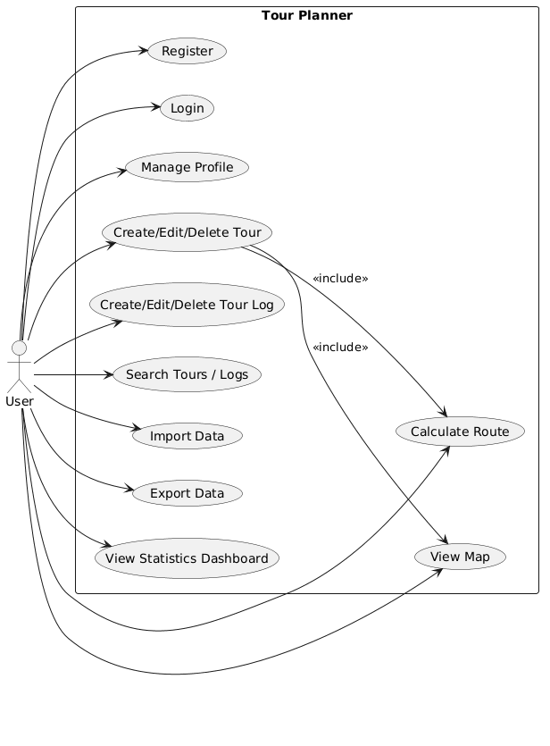

Wireframes / UI Flow
Figma-Link: https://www.figma.com/make/vzG9usKZBdfjT5VZbO7QFL/Tour-List-Dashboard-Wireframe?p=f&t=oR58N5M8hZSy0DCw-0

10.1. Initial Design
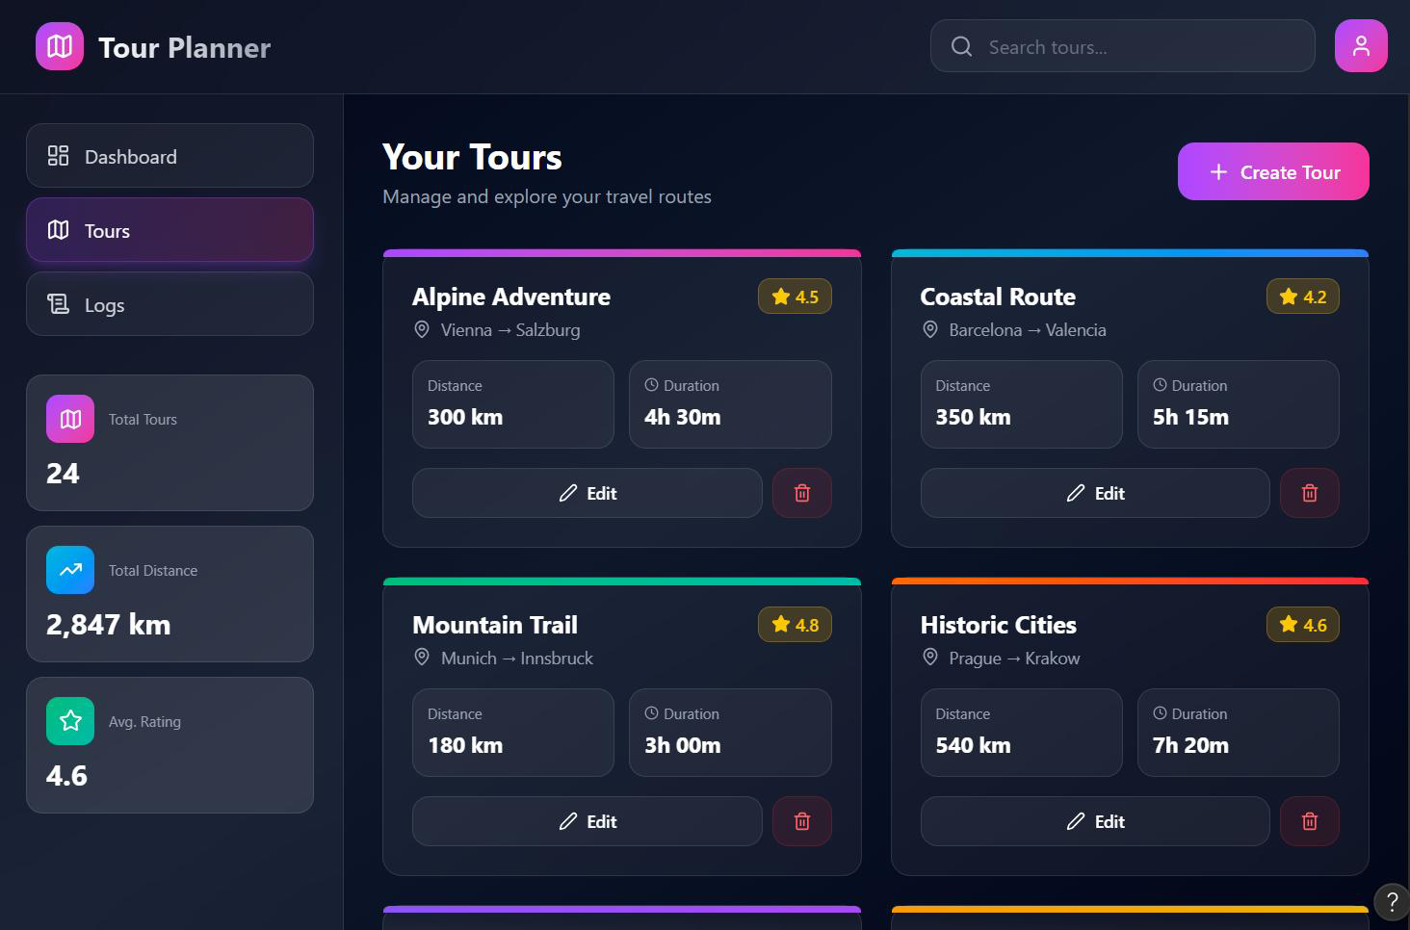

Auth flow
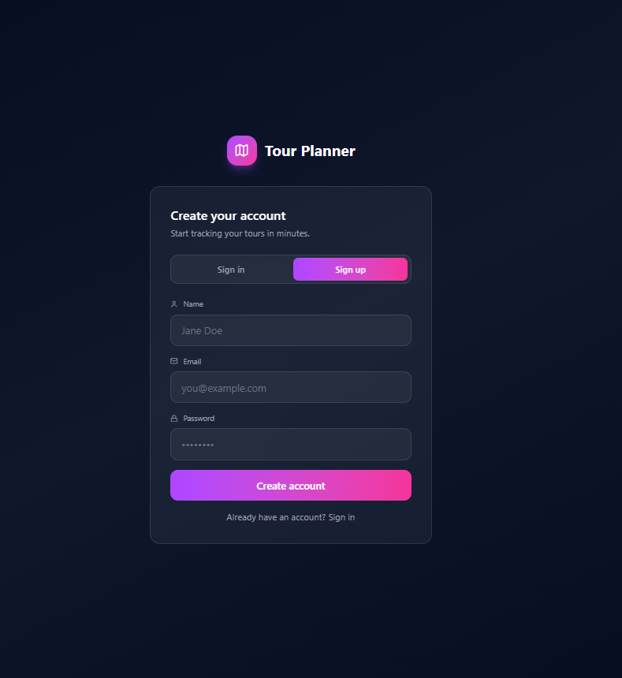
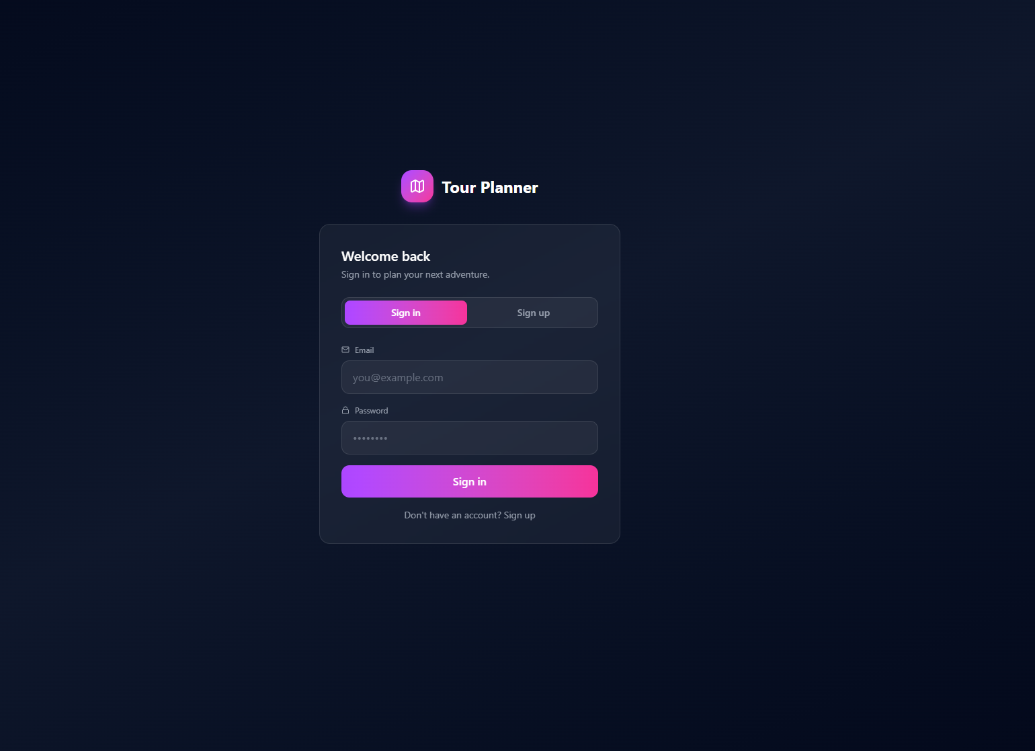

Main app layout
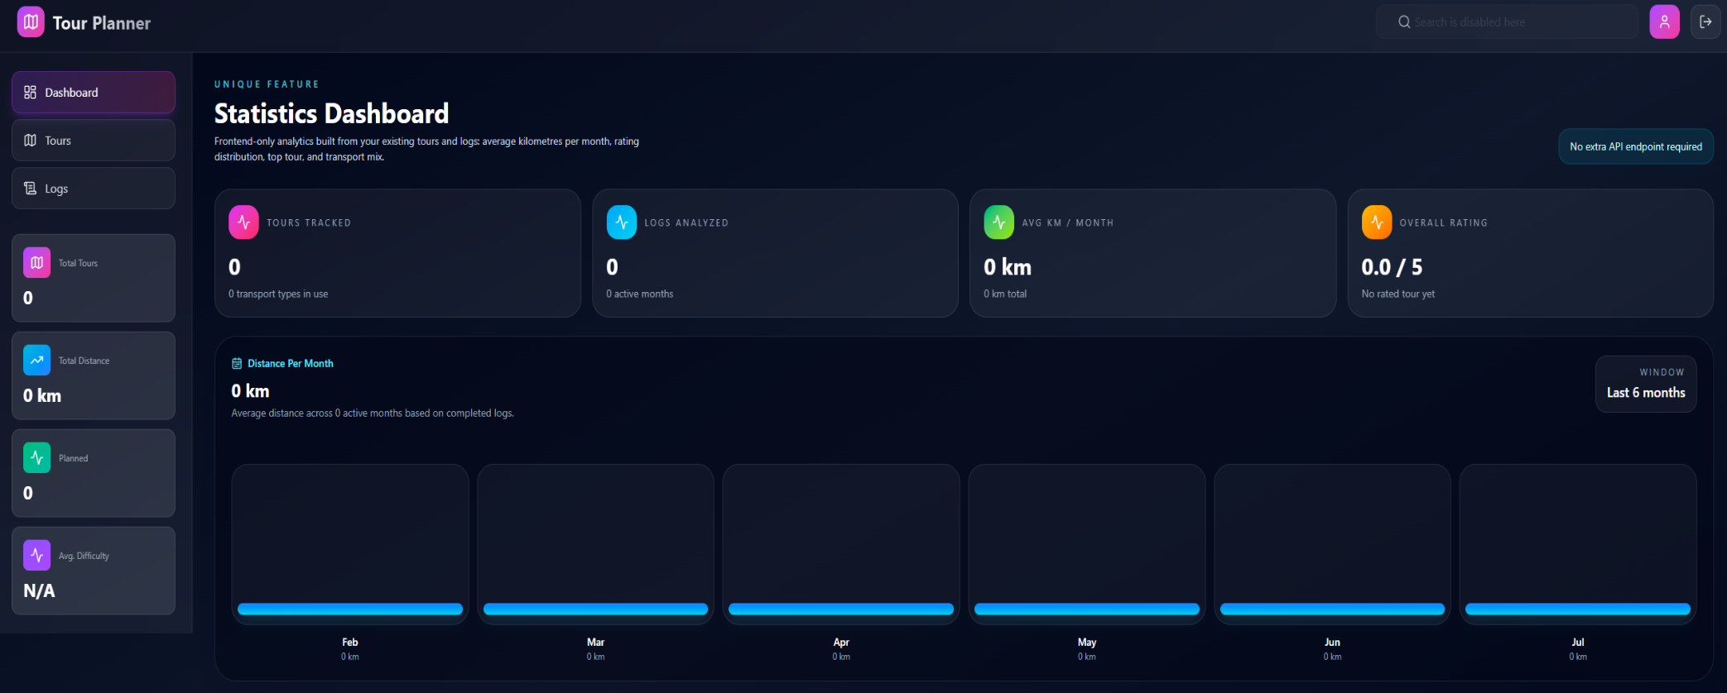

Tours flow
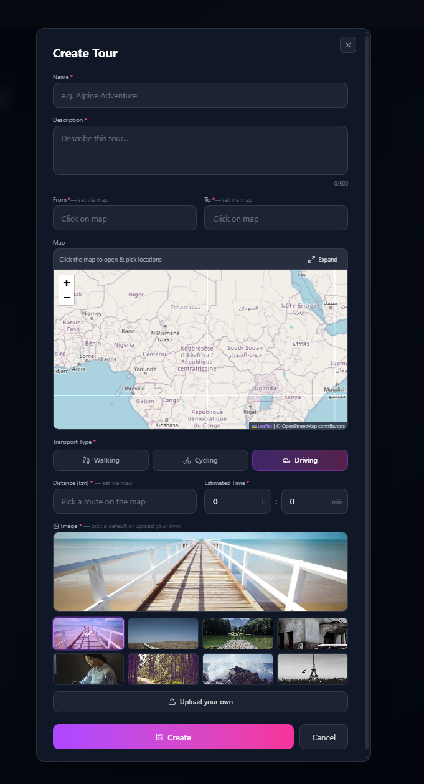
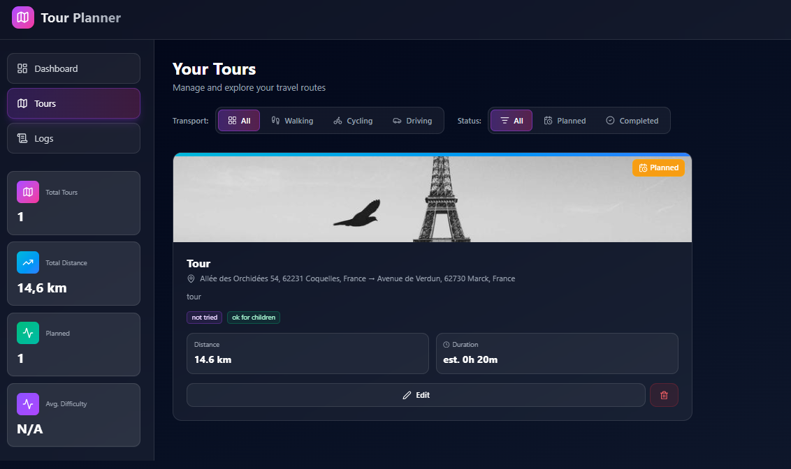

Logs flow
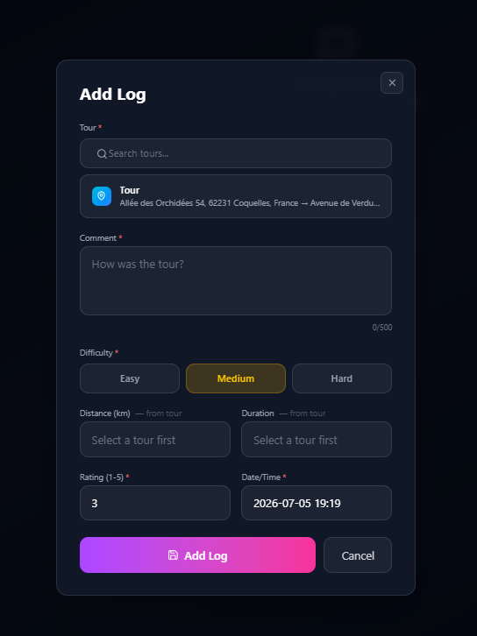

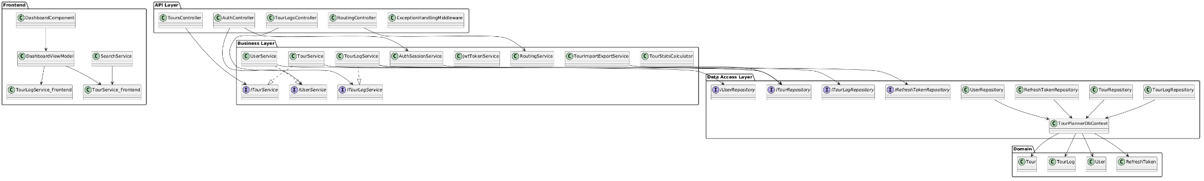
UML Use Case Diagram

UML Use Case Diagram
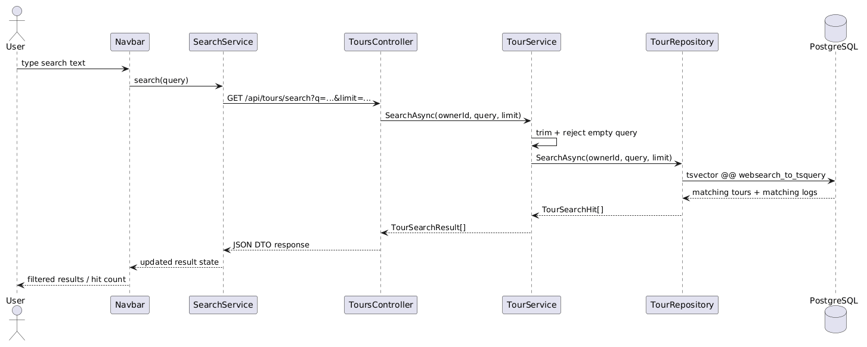
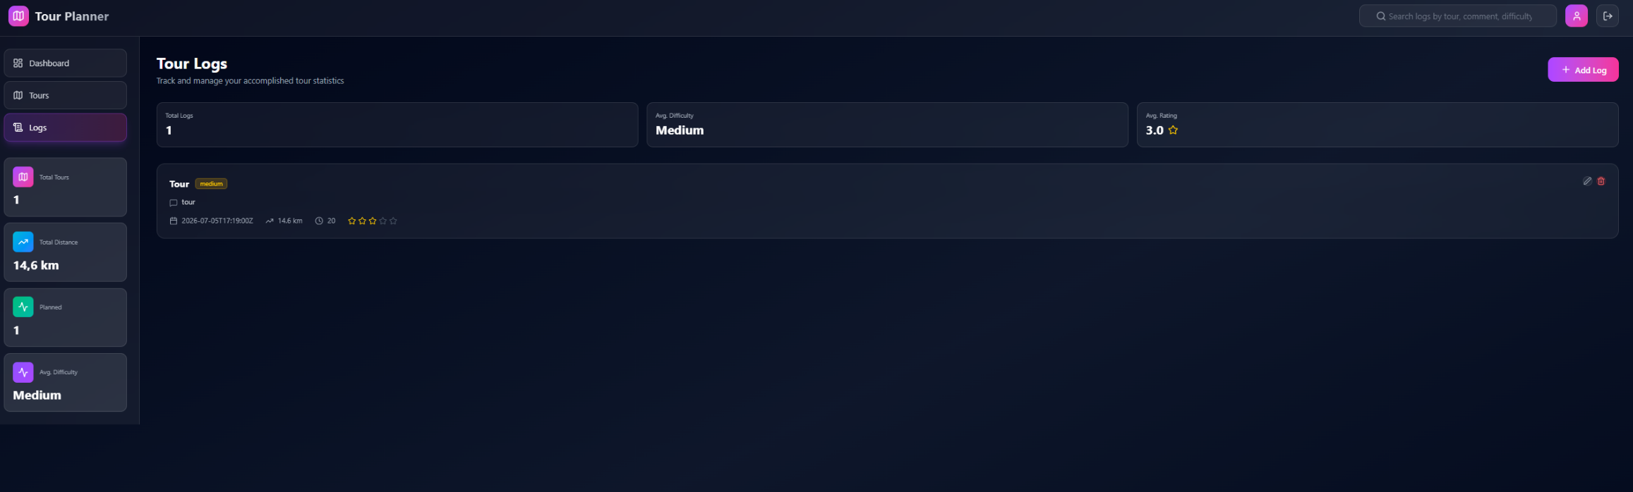

Verification Summary
Verified before hand-in:
- frontend unit tests passed
- frontend production build passed
- backend unit tests passed
- unique feature implemented without extra API endpoint
- startup instructions checked against actual code structure
Known warnings that do not block startup:
- Angular production build is about 25 kB over the configured initial warning budget
- Microsoft.OpenApi currently reports a vulnerability warning during .NET test/build
- there is an EF Core relational version mismatch warning during backend build/test
These warnings should be cleaned up in a follow-up pass, but they did not prevent the application from building or the tests from passing.

Final Conclusion
The project fulfills the intended full-stack structure:
- Angular frontend with MVVM
- ASP.NET Core middleware backend
- layered architecture
- PostgreSQL persistence via EF Core
- external route/map integration
- logging
- automated tests
- import/export
- computed tour statistics
- mandatory unique feature
The unique feature was intentionally kept small and focused: a statistics dashboard that reuses existing tour and log data, avoids new endpoints, and is easy to explain, test, and demonstrate during the final presentation.

